**ANALYSING HOUSING PRICE IN METROPOLITAN AREAS OF INDIA**

1. **INTRODUCTION**

**1.1. OVERVIEW**

**ANALYSING HOUSING PRICE IN METROPOLITAN AREAS OF INDIA IS A MULTIFACETED TASK THAT INVOLVES EXAMINING VARIOUS FACTORS AFFECTING REAL ESTATE MARKETS. THIS STUDY AIMS TO PROVIDE INSIGHTS IN TO THE DYNAMICS OF HOUSING PRICE TRENDS, THEIR DRIVERS AND POTENTIAL IMPLICATIONS. IT WILL EXPLORE FACTORS SUCH AS ECONOMIC CONDITIONS, POPULATION GROUTH, URBANISATION, GOVERNMENT POLICIES AND MARKET DEMAND.**

**1.2. PURPOSE**

**THE PROBLEM STATEMENT FOR ANALYSING HOUSING PRICES IN METROPOLITAN AREAS OF INDIA IS TO INVESTIGATE THE FACTORS CONTRIBUTING TO THE VOLATILE HOUSING PRICE TRENDS IN INDIAN METROPOLITAN AREAS, ASSESS THEIR SOCIO ECONOMIC IMPACTS AND PROPOSE STRATEGIES FOR ADDRESSING AFFORDABILITY CHALLENGES. THIS PROBLEM STATEMENT HIGHLIGHTS THE NEED TO UNDERSTAND THE UNDERLYING CAUSES OF HOUSING PRICE FLUCTUATIONS, THE CONSEQUENCES OF THESE FLUCTUATIONS ON SOCIETY AND THE FORMULATION OF STRATEGIES TO MITIGATE ISSUES RELATED TO HOUSING AFFORDABILITY.**

1. **PROBLEM STATEMENT**

**2.1. EMPATHY MAP**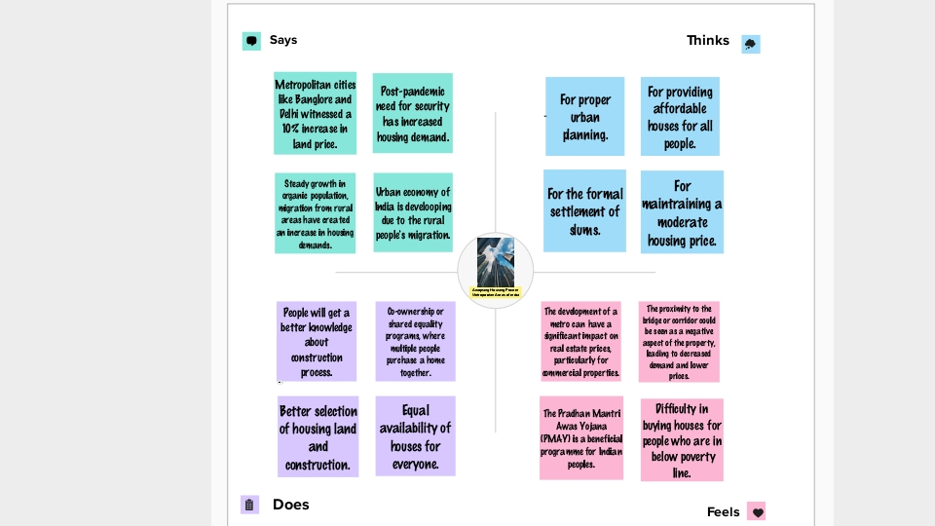

**2.2. BRAINSTORM AND IDEA PRIORITIZATION**

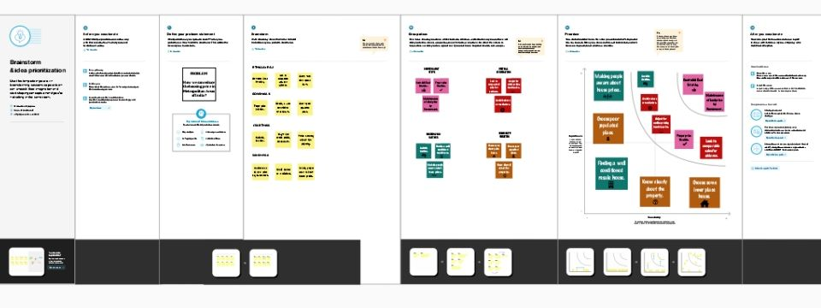

1. **RESULT**

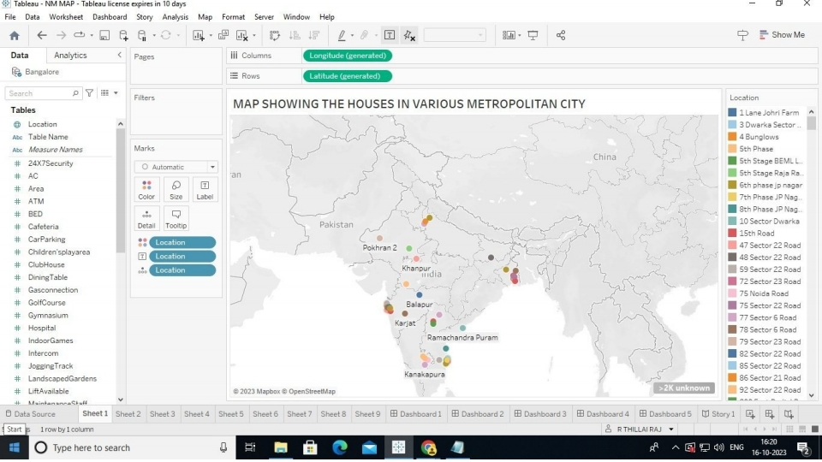

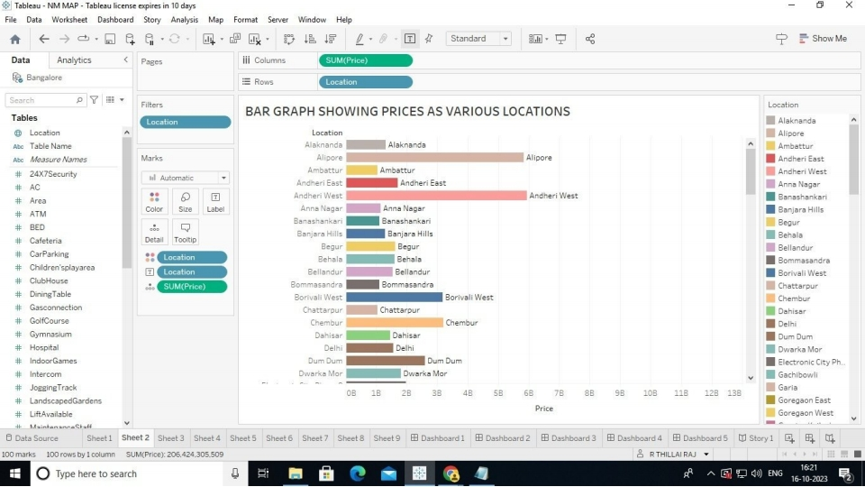

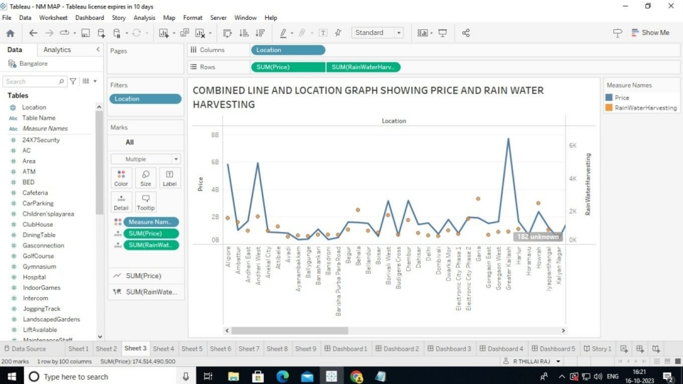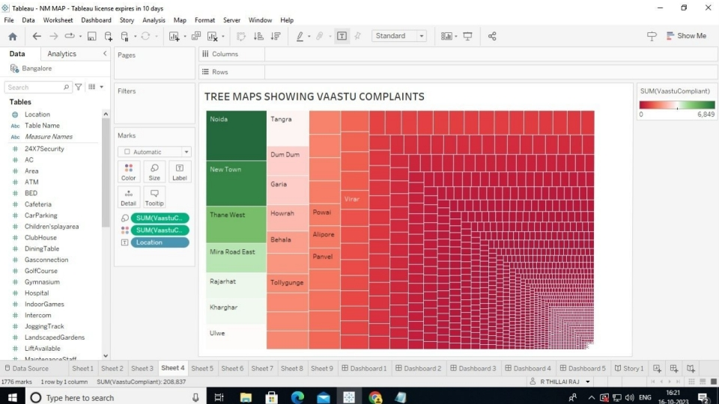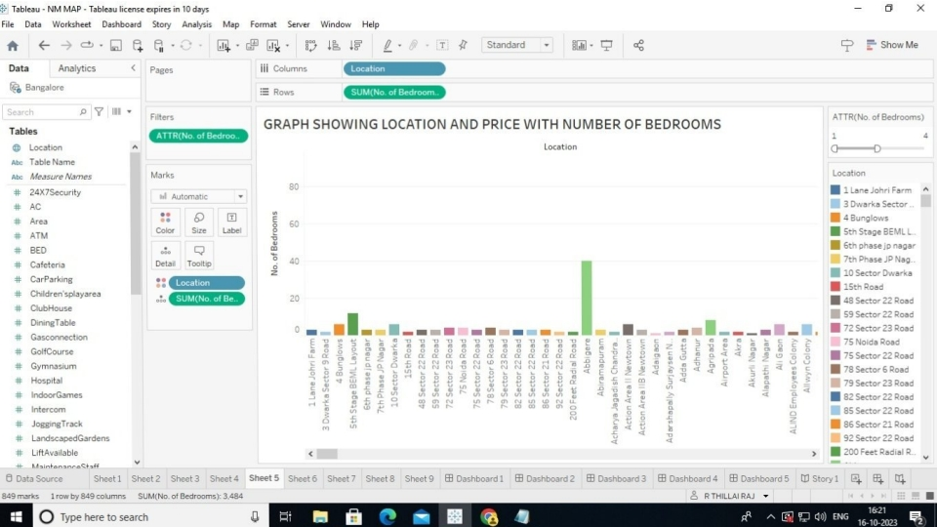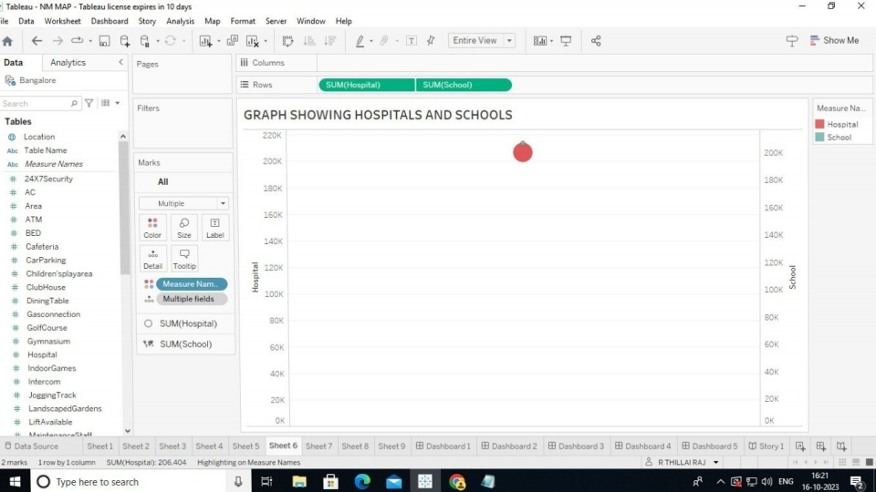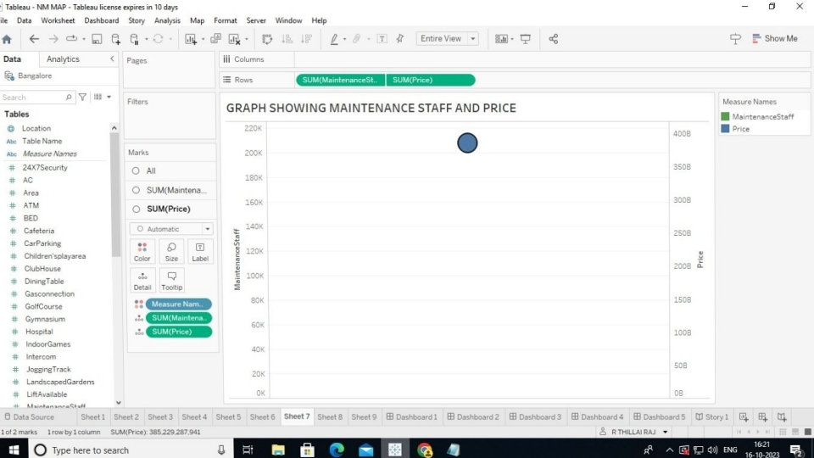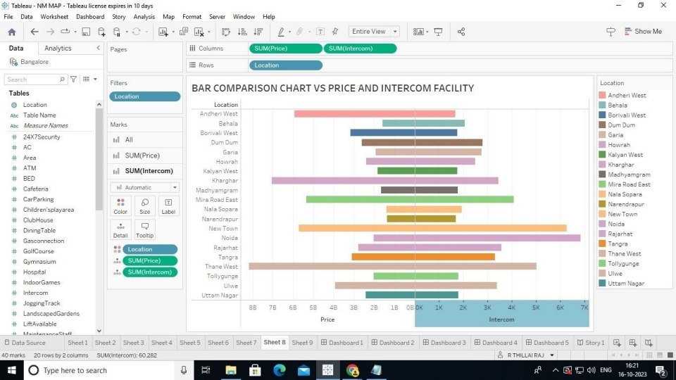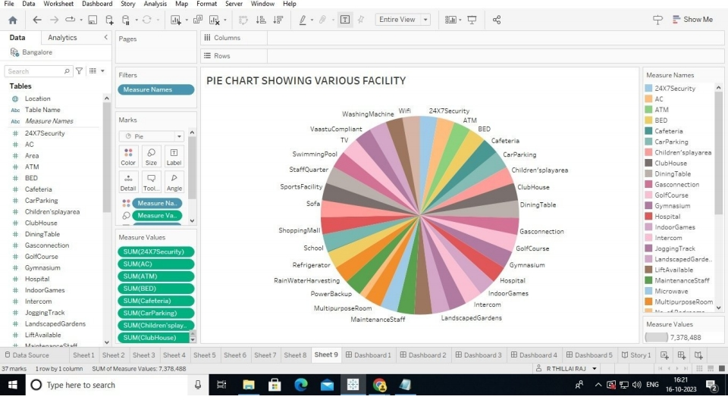

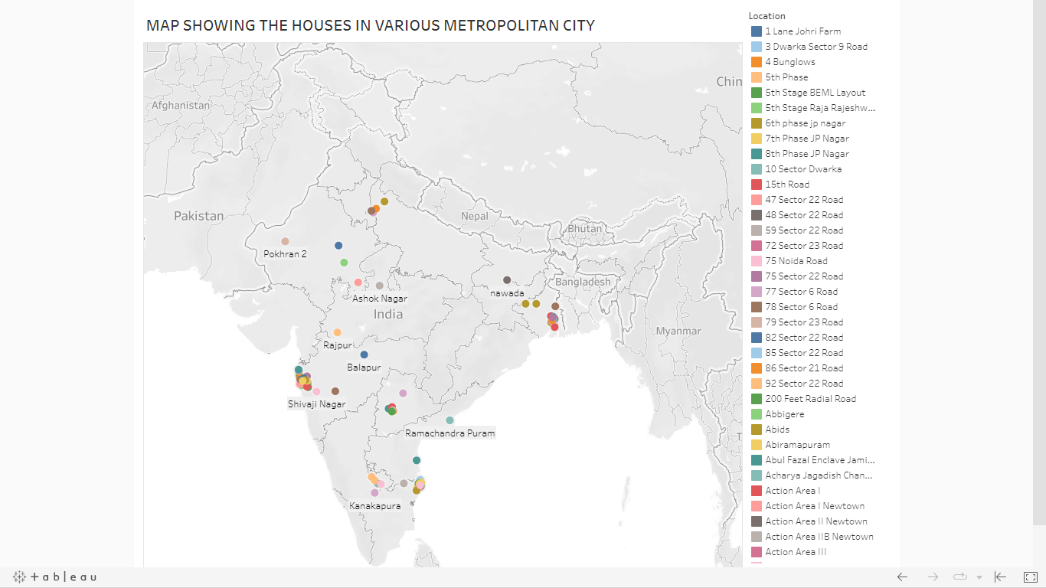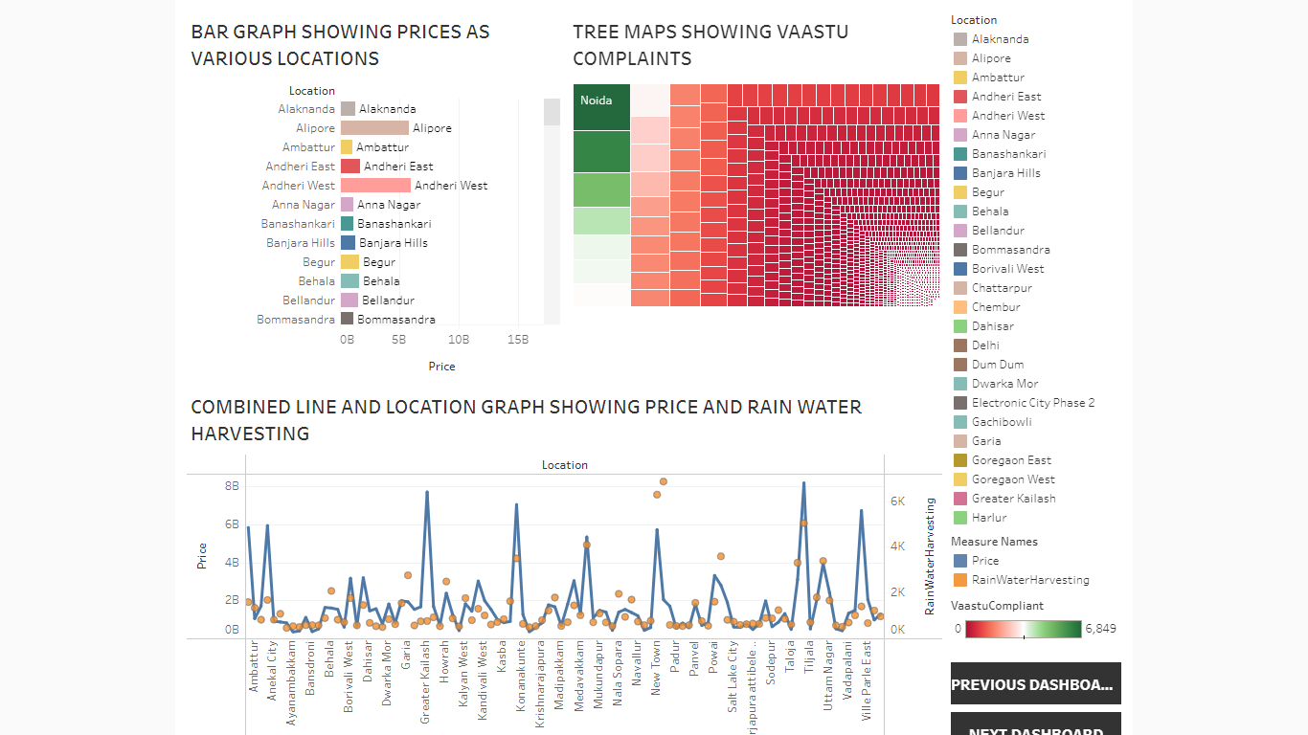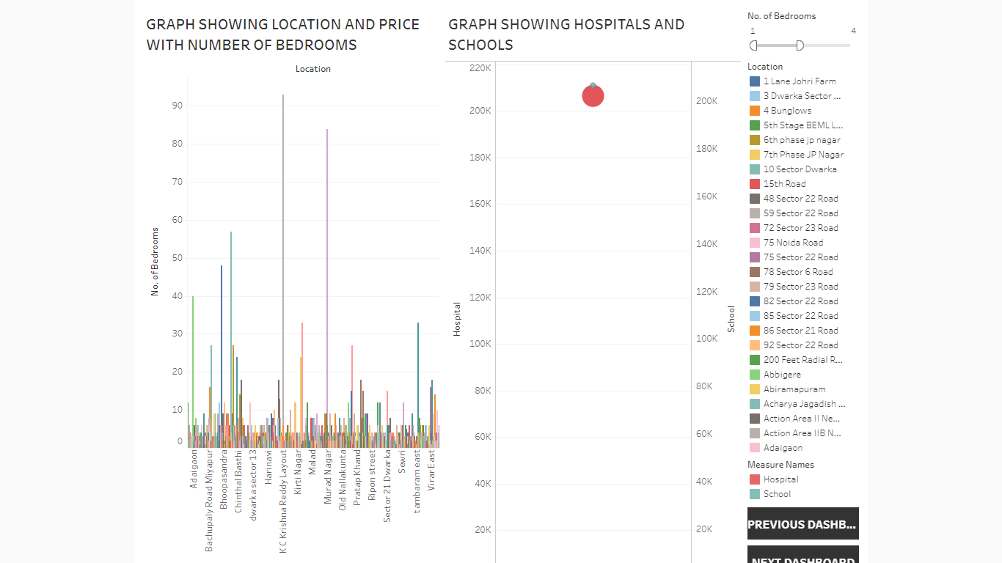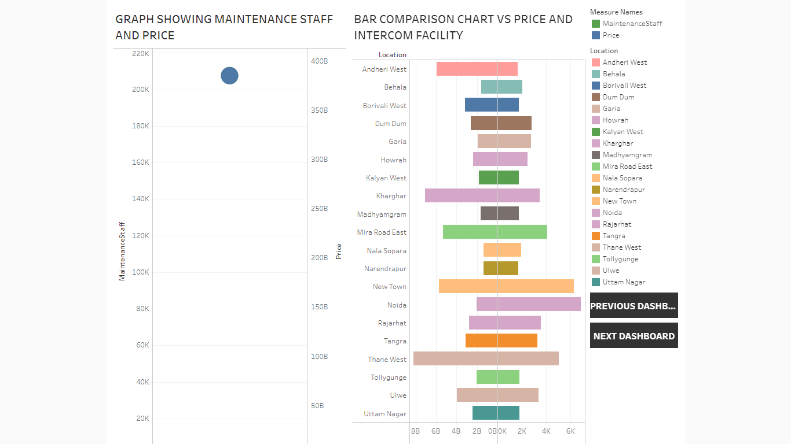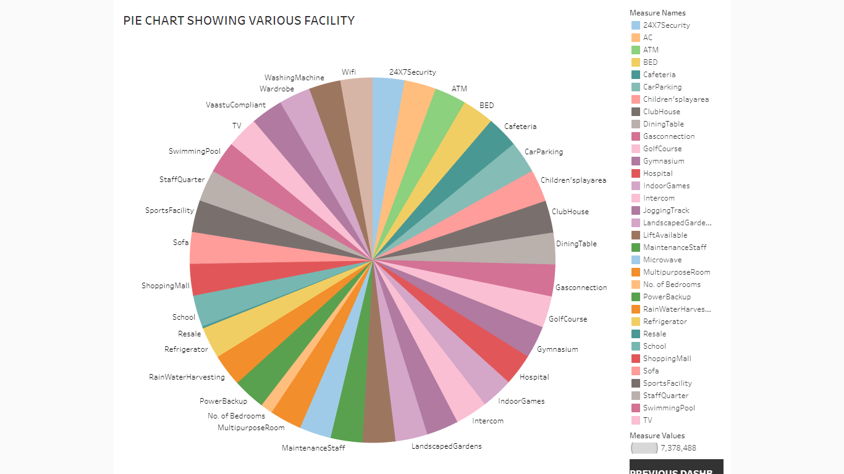

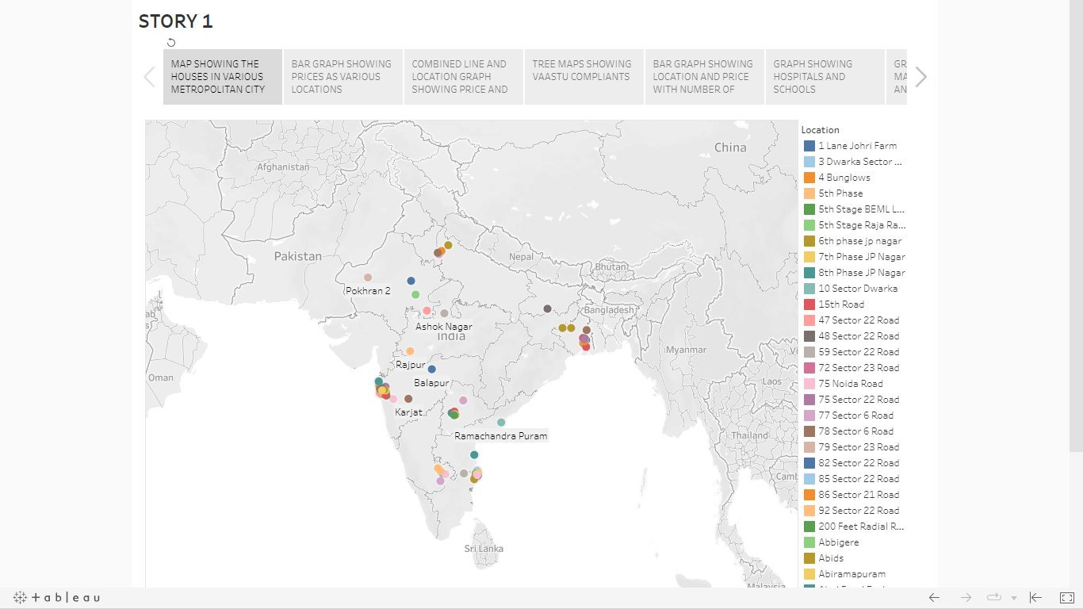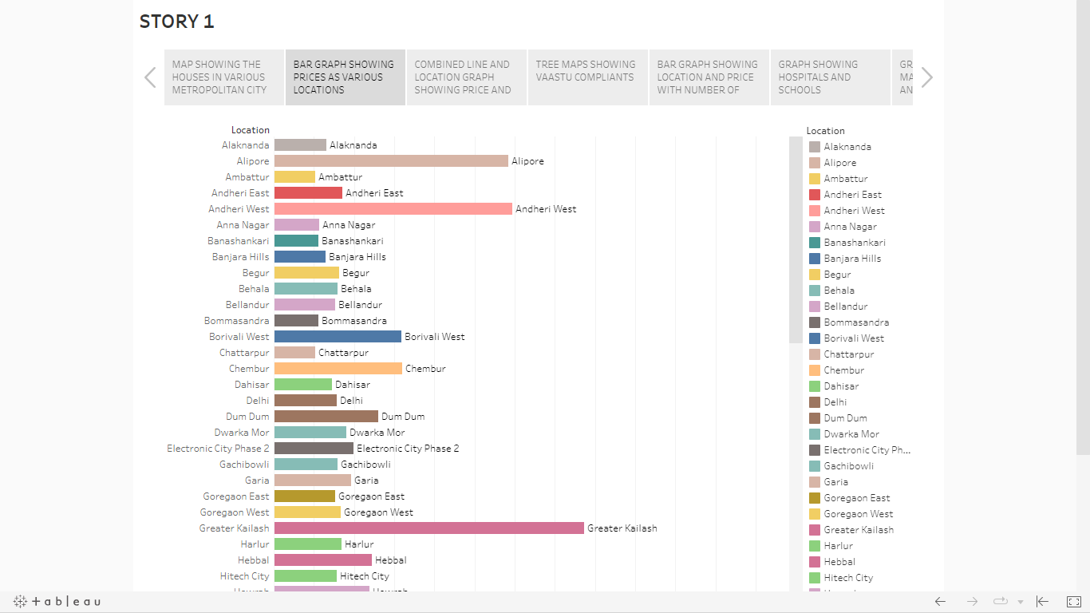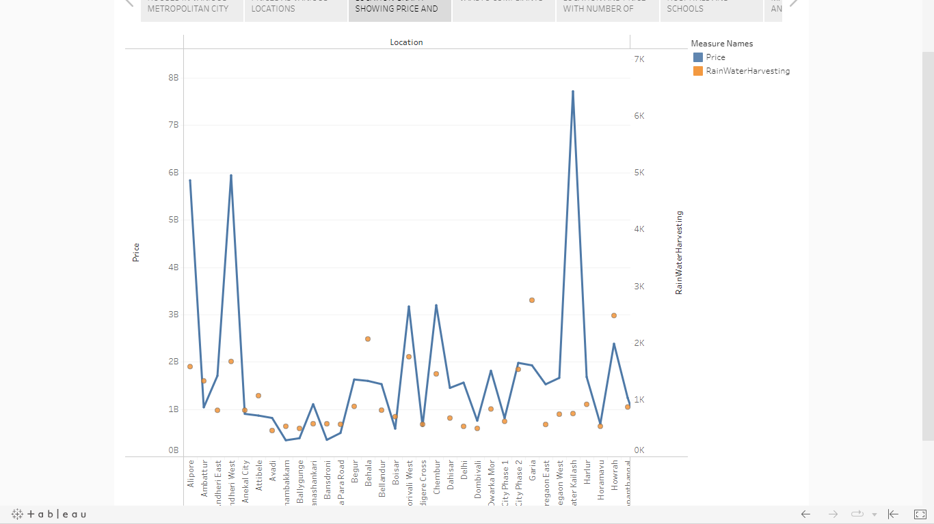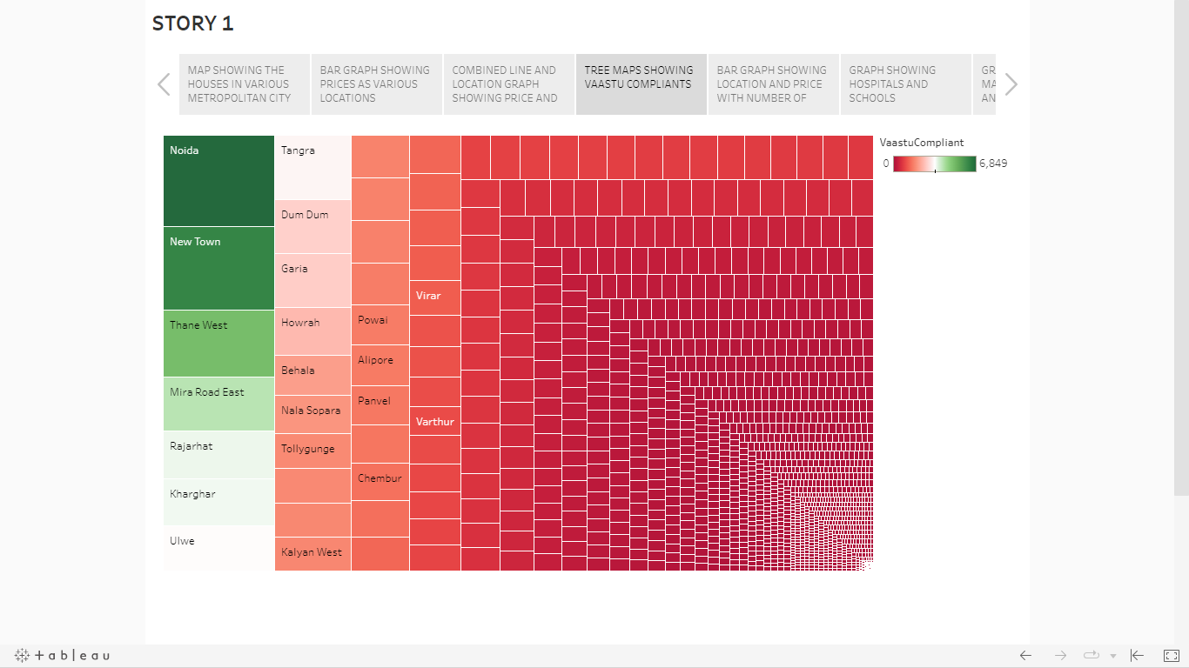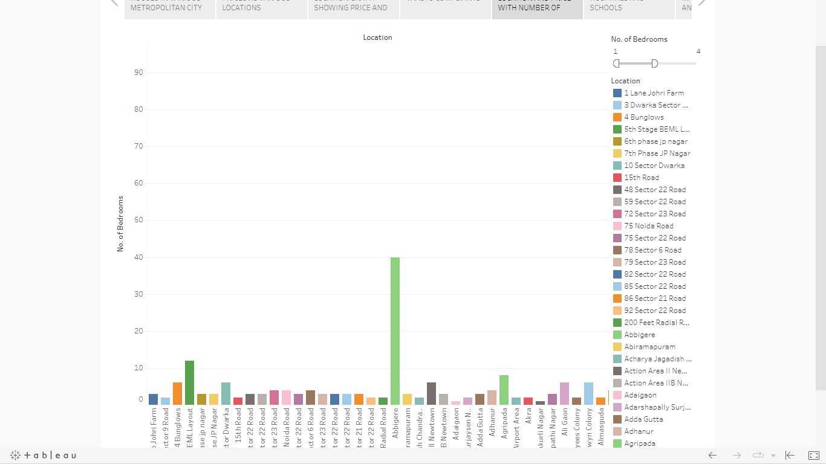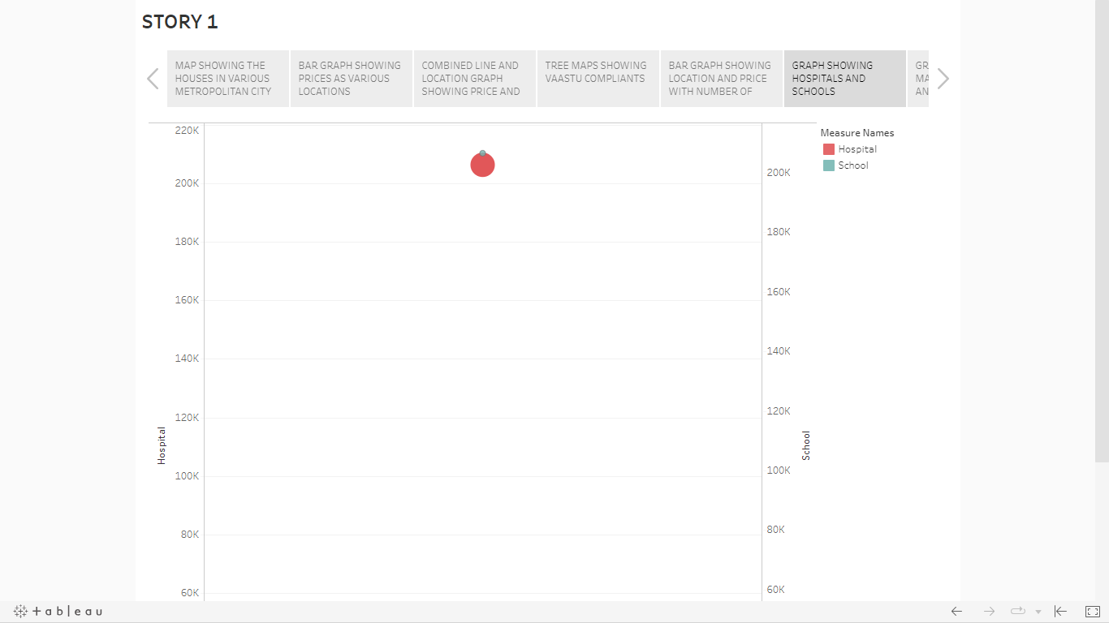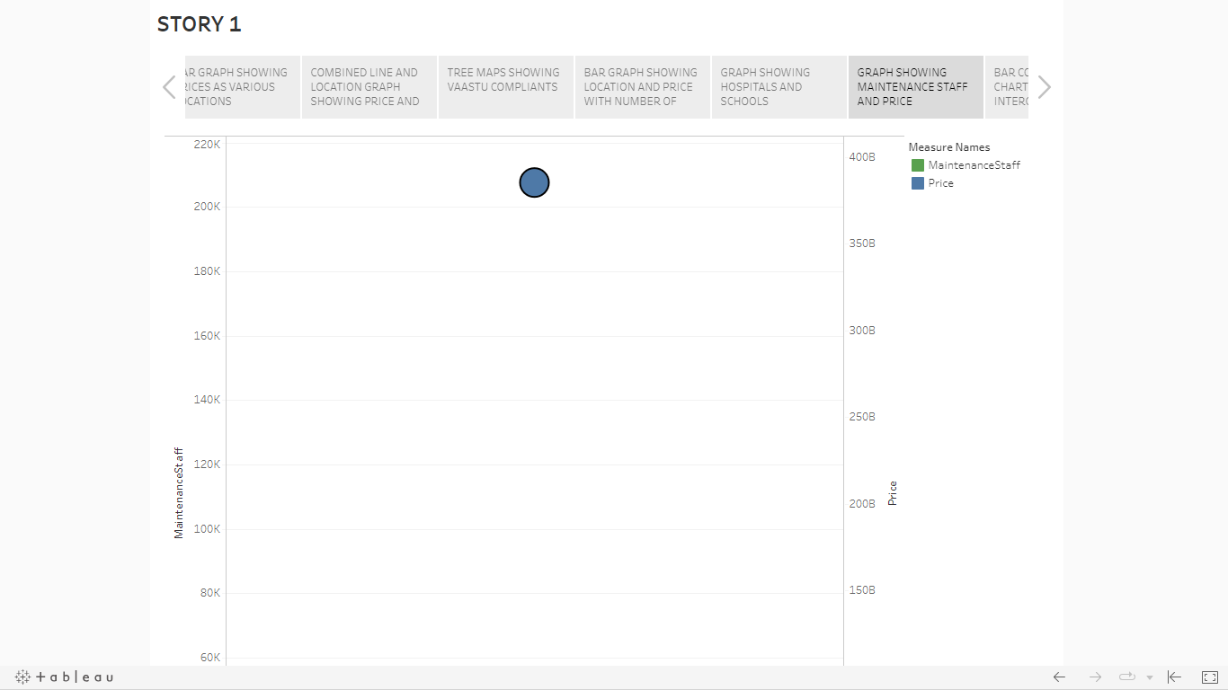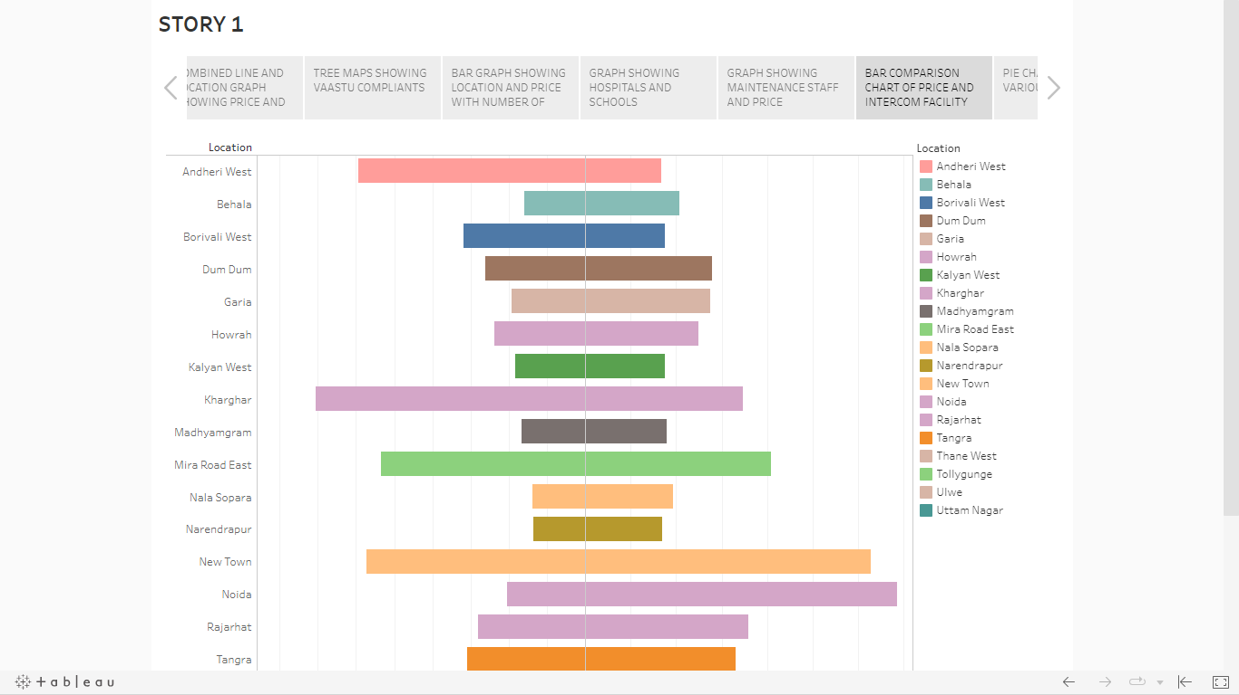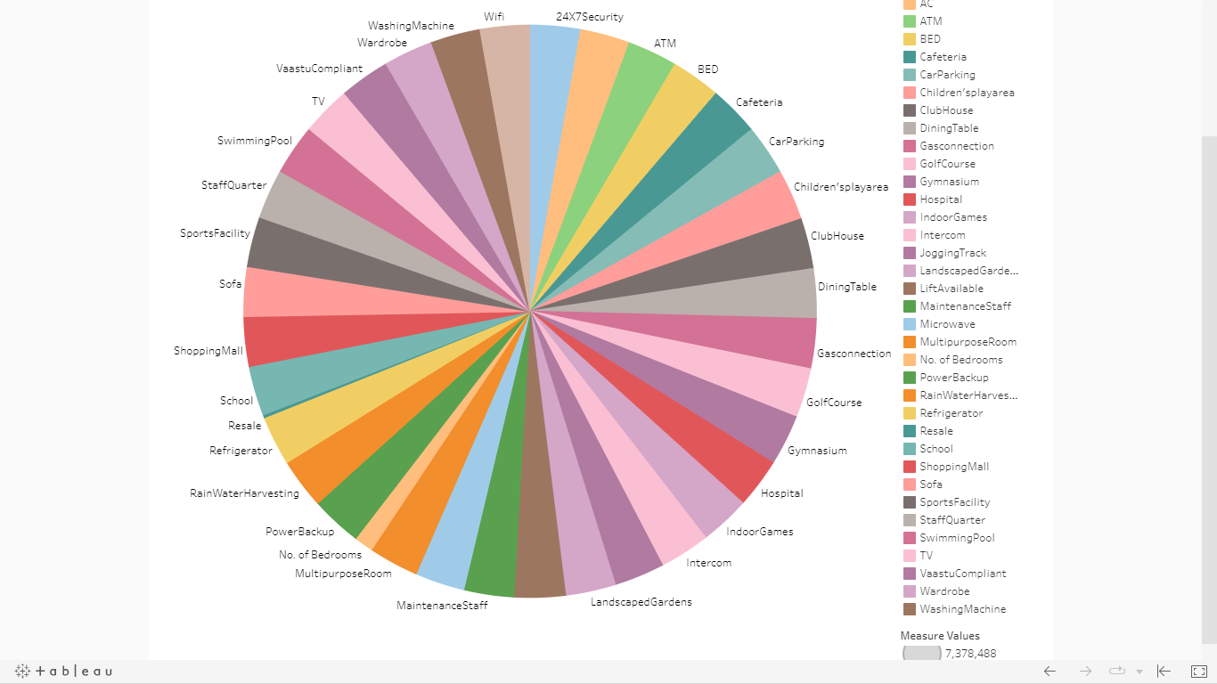

1. **ADVANTAGES AND DISADVANTAGES**

**4.1. ADVANTAGES**

1. **INFORMED DECISION MAKING:**

**ANALSIS OF HOUSING PRICE EMPOWERS INDIVIDUALS , BUSINESSES AND POLICY MAKERS TO MAKE INFORMED DECISIONS ABOUT PROPERTY INVESTMENT, POLICIES AND URBAN DEVELOPMENT.**

1. **ECONOMIC INSIGHT:**

**HOUSING PRICE ANALYSIS CAN SERVE AS A BAROMETER FOR THE OVERALL HEALTH OF THE ECONOMY, CONSUMER SENTIMENT AND FINANCIAL STABILITY.**

1. **INVESTMENT OPPURTUNITIES:**

**INVESTERS CAN IDENTIFY OPPURTUNITIES AND INCREASE THEIR INVESTMENT MORE EFFECTIVELY BY UNDERSTANDING HOUSING PRICE TRENDS.**

**4.2. DISADVANTAGES**

1. **UNPREDICTABLE FACTORS:**

**HOUSING MARKETS CAN BE INFLUENCED BY UNPREDICTABLE EVENTS LIKE ECONOMIC CRISIS, NATURAL DISASTERS AND PANDEMIC MAKING LONG-TERM FORCASTING DIFFICULT.**

1. **GENTRIFICATION CONCERN:**

**RISING HOUSING PRICES CAN LEAD TO GENTRIFICATION, DISPLACING LOW-INCOME RESIDENCE AND ALTERING THE SOCIAL FABRIC OF COMMUNITIES.**

1. **DATA AVAILABILITY:**

**IN SOME CASES RELIABLE AND UPTO DATE HOUSING PRICE DATA MAY BE LIMITED, HINDERING THE ACCURACY OF THE ANALYSIS.**

**5. APPLICATIONS**

1. **REAL ESTATE INVESTMENT:**

**POTENTIAL REAL ESTATE INVESTERS CAN USE THIS ANALYSIS TO IDENTIFY PRIME LOCATIONS AND TIMING FOR PROPERTY INVESTMENTS.**

1. **HOME BUYERS:**

**INDIVIDUALS LOOKING TO PURCHASE HOMES CAN USE THE DATA TO FIND AFFORDABLE OPTIONS AND MAKE INFORMED DECISIONS ABOUT WHERE TO BUY BASED ON THEIR BUDGET AND FUTURE FINANCIAL GOALS.**

1. **URBAN PLANNING:**

**CITY PLANNERS AND LOCAL AUTHORITIES CAN LEVERAGE HOUSING PRICE ANALYSIS TO MAKE DECISIONS ABOUT INFRASTRUCTURE DEVELOPMENT, ZONING REGULATIONS AND LAND USE POLICIES TO ACCOMMODATE POPULATION GROWTH.**

**6. CONCLUSION**

**ANALYSING HOUSING PRICES IN METROPOLITAN AREAS OF INDIA IS A MULTIFACETED ENDEAVOR WITH SIGNIFICANT INPLICATION FOR INDIVIDUALS, BUSINESSES, POLICY MAKERS AND RESEARCHERS. THIS ANALYSIS PROVIDES INSIGHTS INTO THE COMPLEXITIES REALESTATE MARKETS, OFFERING A VALUABLE PERSPECTIVE ON TRENDS, DRIVERS AND CONSEQUENCES OF HOUSING PRICE FLUCTUATIONS.**

**7. FUTURE SCOPE**

1. **DATA ANALYTICS AND TECHNOLOGY:**

**ADVANCES IN DATA ANALYTICS, MACHINE LEARING AND ARTIFICIAL INTELLIGENCE WILL ENABLE MORE ACCURATE AND REAL-TIME ANALYSIS OF HOUSING PRICE TRENDS, ENHANCING THE PREDICTIVE CAPABILTIES OF SUCH STUDIES.**

1. **AFFORDABLE HOUSING SOLUTIONS:**

**WITH CONTINUOUS URBANISATION, THERE WILL BE A GROWING NEED FOR INNOVATIVE AND AFFORDABLE HOUSING SOLUTIONS. FUTURE RESEARCH CAN FOCUS ON IDENTIFYING SUSTAINABLE AND COST-EFFECTIVE HOUSING MODELS.**

1. **GLOBAL COMPARISON:**

**COMPARATIVE STUDIES WITH OTHER COUNTRIES HOUSING MARKETS CAN OFFER INSIGHTS INTO BEST PRACTICES AND INNOVATIVE APPROCHES FOR ADDRESSING HOUSING RELATED CHALLENGES.**